The Dzaqtlas Adventure

A Supplement for Traveller set in the Zhodani Second Dark Age

Jeff Kazmierski

  Dlolpliki, Zhdant

Front cover reverse

*The Dzaqtlas Adventure*

*A Traveller Adventure Supplement*

*For adventures in the Zhodani Second Dark Age*

Jeff Kazmierski

In assocaition with

The men and women of the Zhdantia Language and Cultural Institute

With special thanks to P. O. Bergstedt for creating the ZhoGlyph truetype font

Interior illustrations by Jeff Kazmierski

And thanks, and appreciation to Marc Miller, J Andrew Keith, John Harshman, and the GDW/Far Future Enterprises team for creating Traveller. Thank you for 45 years of incredible science fiction gaming!

First Edition 2022

Copyright © 2022

The Zhdantia Language and Cultural Institute

Contents

*DZAQTLAS!* 1

Timeline of the Dzaqtlas Era 3

Zhodani CHARACTERS 5

Initial character creation 5

Social Status 5

Psionics: 6

Homeworld: 6

Zhdant of the Dzaqtlas Era 7

*DZAQṪAS*

*DZAQTLAS!*

*The cities are empty now, dead and decaying remnants of the old world. When the plague arrived, it struck without warning, a silent, deadly force that killed man, woman, and child with neither mercy nor malice. We were unprepared for such a thing.*

*We had ascended to great heights and had begun reaching for the stars… our moon, Viepchakl, was naturally our first step into the dark of space beyond. Upon its desolate surface we found, to our delight and surprise, another people like our own Zhdantia neighbors. We called them the Viepchaklts, and we welcomed them to our home.*

*We had no way to know at the time that it would be our undoing.*

*In our arrogance and hubris, we reached for the stars, and the gods put us in our place.*

*Now the scattered remnants of humanity fight for scraps among the ruins.*

Of all the historical events that shaped Zhdantia culture in its nearly 300,000 year history, few rival the plague event known as the **Dzaqtlas (**DZAQṪAS), which brought about the end of the first Industrial Age.

Prior to the **Dzaqtlas**, Zhdant was home to not one but two sapient species, the offshoot of humaniti that would later become known as *Nad Zhdotlas*, and a non-human species known as the *Chirpers* or **Qiknavrats**, as the humans of Zhdant called them.

The **Qiknavrats** (QIKNAṼAṮ), like the Zhdantia humans, had long been known to be alien to Zhdant. While their actual history was unknown at the time, they were, in fact, a regressed offshoot of another non-human species called the *Droyne,* themselves descendents of a long-dead species of creatures known only as the *Ancients.* The **Qiknavrats** were discovered on Zhdant’s smaller continent, Qiknavra, and in the succeeding centuries, the humans of Zhdant traded and occasionally made war with them and both species prospered.

The cultural and technological exchanges between the two species brought unprecedented advancement and growth. The humans had technology to trade; the Chirpers had a unique skill that fascinated and intrigued the humans – psionics. Though to the technologically focused humans this new skill was little more than amusing parlor tricks, it would later become critical to their survival.

By c. Imperial year -7980 (-550 by the Zhdantia calendar, about 3500 BCE), when Terran humans were still discovering bronze tools, Zhdantia humans and their Qiknavrats friends took their first steps into space. Orbital flights soon became routine, and exploration of Zhdant’s moon **Viepchakl** (VĪPĈAḰ) had begun. To their surprise and mutual delight, the explorers discovered another species of *Chirper* living on Viepchakl, whom they named the **Viepchaklts** (VĪPĈAḰṮ), or *People of Viepchakl*. Intercultural exchanges began between the three species, with representatives of both **Qiknavrats** and **Viepchaklts** visiting each other’s home planet.

Unfortunately, unknown to all three peoples, the Viepchakl explorations unleashed an ancient, long-dormant biological weapon left behind thousands of years earlier. Within a few years the entire Chirper population of both worlds was extinct and nearly two-thirds of the human population was dead.

The **Dzaqtlas**, as the plague would be called, erased nearly all the technological and socio-economic gains of the previous millennia. Because of their alien biology, neither the Zhdantia nor the Chirpers had any prior experience with serious diseases. Medical technology was underdeveloped due to the lack of necessity. As a result, human civilization on Zhdant reverted to barbarism as entire cities were emptied in a futile attempt to avoid the plague’s effects. For the next thousand years Zhdant experienced a Second Dark Age during which the population slowly recovered.

It is not clearly known when psionics rose to prominence, but it is likely that it played a role in the recovery. At some point during the Second Dark Age, some tribes or kingdoms discovered that certain psionically adept individuals could resist the effects of the **Dzaqtlas**, which had remained dormant years later. Others could use their mysterious power to heal others. Eventually the western kingdoms of Dleqiats began embracing psionic healers and other psionic adepts and using them to expand their influence and power. A code of ethics and service like the Terran code of Chivarly was developed – the **Tavrziansh** (TAṼZĨNŚ), or *Morality’s Path* that defines Zhdantia culture even today.

The empire building through psionic development and moral guidance enabled the newly emergent Zhdantia society to recover and prosper again, and within a few hundred years of the end of the Second Dark Age, Zhdantia humans had once again achieved space flight and began returning to Viepchakl and beyond[1].

This supplement will cover how to create characters for play during the time of the Zhdantia Second Dark Age. You will need a copy of both the Mongoose Traveller core rules and *Mongoose Alien Module 4: Zhodani*. A copy of *Beginning Zdetl* published by the Zhdantia Language and Cultural Institute may be useful but is not necessary.

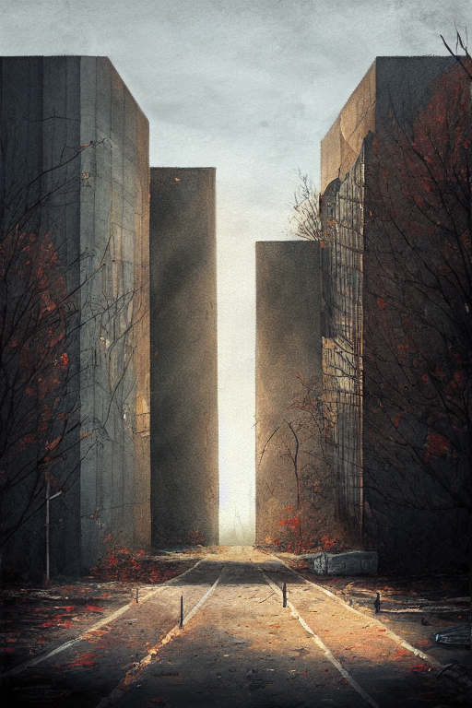

# Timeline of the Dzaqtlas Era

|  |  |  |
| --- | --- | --- |
| Imperial Year | Zhodani Year | Event |
| -302,000 | -392316 | Ancients arrive on Zhdant with proto-Zhodani humans. |
| -300,000 | -389659 | Extensive development of Qiknavra by Ancients |
| -299,700 | -389260 | Final War results in devastation of Zhdant. |
| -280,000 | -363085 | Nuclear winter follows; beginning of First Ice Age. |
| -275,000 | -356441 | End of First Ice Age. |
| -260,000 | -336511 | Nomadic human hunter-gatherer tribes range across Dleqiats. |
| -250,000 | -323224 | Huts, fishing developed. |
| -240,000 | -309937 | *Nad zhdatl* emergent on northern Dleqiats. |
| -200,000 | -256788 | *Nad vlastebr* emerges on southern Dleqiats. *Qiknavrats* rediscover agriculture. |
| -150,000 | -190353 | Human races clash: interbreeding creates *Nad zhdotlas.* |
| -100,000 | -123918 | Qiknavrats establish two large, static empires on Qiknavra. |
| -80,000 | -97344 | Second Ice Age begins. |
| -40,000 | -44195 | Second Ice Age ends. |
| -30,000 | -30908 | Animal herding and breeding. |
| -24,000 | -22936 | Special domesticated breeds emerge. |
| -18,000 | -14964 | *Nad zhdotlas* develops agriculture and fishing. |
| -17,000 | -13635 | Zhodani Iron Age. *Viepchaklashtie* Empire founded. |
| -15,000 | -10978 | *Viepchaklashtie* Empire at its peak. |
| -13,000 | -8320 | *Viepchaklashtie* Empire collapses. Beginning of First Dark Age. |
| -9000 | -3006 | Rise of noble classes and feudalism. |
| -8590 | -2461 | End of First Dark Age. Beginning of first Age of Enlightenment. |
| -8550 | -2408 | Invention of the printing press. |
| -8540 | -2394 | Ocean trade. Discovery of Qiknavra. |
| -8530 | -2381 | First Zhodani contact with *Qiknavrats.* |
| -8500 | -2341 | Invention of movable type |
| -8300 | -2075 | Development of elementary psionics. |
| -8200 | -1943 | First Industrial Revolution. |
| -8000 | -1677 | Warfare between Dleqiats and Qiknavra. |
| -7980 | -1650 | Uneasy peace between the continents. |
| -7959 | -1622 | First orbital space exploration. |
| -7,950 | -1610 | First expedition to Viepchakl. |
| -7,949 | -1609 | Viepchakl base. First contact with Viepchaklts. |
| -7,948 | -1608 | First meeting between *Qiknavrats* and *Viepchaklts.* |
| -7,945 | -1604 | Beginning of the *Dzaqtlas*. |
| -7,940 | -1597 | Second Dark Age begins |
| -7,920 | -1571 | Rise of the *Dlenchiepr* empire on Western Dleqiats. Noble houses begin incorporating psionicists as part of their retinue. |
| *-7,800* | ***-1411*** | ***Present Day.*** |
| -6,800 | -82 | Recovery. Rise of psionics. |
| -6,738 | 1 | First Teqozdievl. |

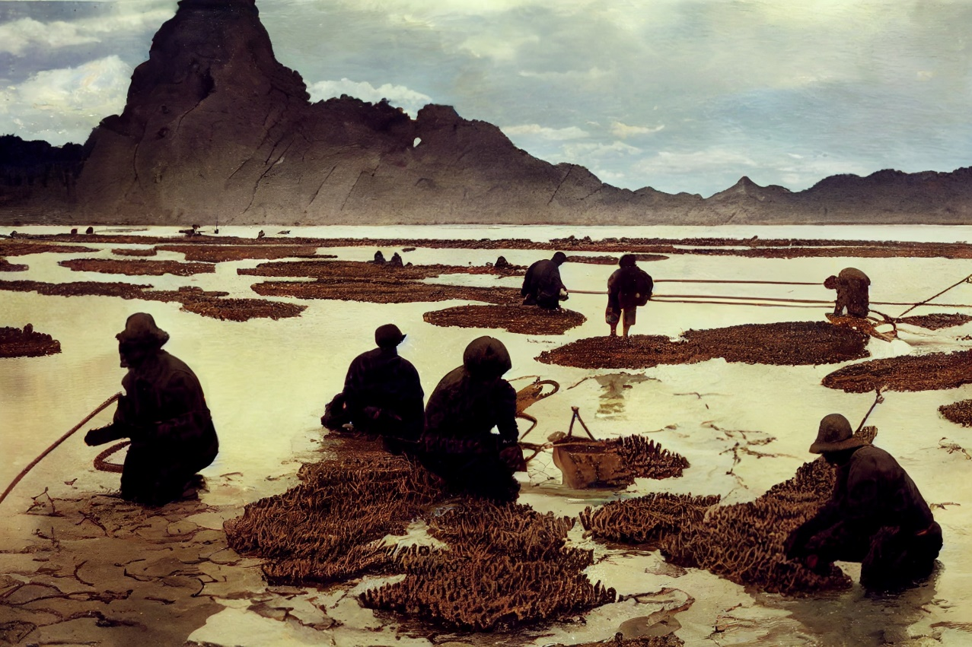

‘See, Mazhotla, the lagoon has begun to bring forth new brood. You children there! Watch that gap in the net, ere the flyers scoop up too many of the tads!’

Dzalo had come over the Tall Ridge from the North with her Gift the year before last. I had been on watch that five-day, at the post overlooking the Pass from the mountains. She’d come alone, half-mad from thirst, and she’d been on the road long enough to wait for the Wise Man to come check her for the Horribleness. Dzalo had carried something, alright, but it hadn’t been contagion.

‘We can take the spawners out now,’ Dzalo went on, ‘before they too eat too much of the brood themselves.’

‘Back to the main pen with them, then?’ I looked over at the hooked poles and scoop nets hung carefully- per her instructions- on the side of the Keeper’s shed. I was studying with Dzalo ever since the Baz sling stone had cracked my knee two months gone. I couldn’t walk the tall, steep trails up to the watch posts anymore.

‘Yes. Get two of the larger children to help you. You know how slippery these are.’

I whistled for Talizl and Zoqtan. ‘Come help me get the breeders out of the lagoon.’ They’d been working with Dzalo since the Council agreed to her plan, which back then sounded purely insane. We’d all dug the lagoon, near starving, eating the last of the stores save what would keep us barely alive until Dzalo’s plan came to fruition. Many of us had been skeptical, but there was little left we could do once the Baz had cut off the road to the lower reaches of the Valley.

Dzalo’s ‘Gift’ hadn’t seemed like much. A leather bag holding a smaller sealed bag of the ‘plastic’ used before the Horribleness had descended on the World, filled with slimy, shriveled green-grey spheroids. ‘I had to flee from the Northern Valley when the Baz brought the Horribleness and madness upon our village. I took the one thing we had and no one else did, to save the lives of whomever would take me in.’

There had been a large, old disused metal water tank, used in the Old Days for no one remembered what. We removed its roof, filled it with water from the River and some orange water weed and let the Sun warm it and make the weed proliferate. Some old netting kept the flyers from getting to the water. An odd request from an odd woman, even odder when she then dumped most of her Gift into the warm water . . .

Now the slimy four-leggers that had hatched out of the green-gray nodules fed the two hundred in our Village and two others beside. They traded their lumber, salt, and the things gleaned from the ruins of the Old Town many kilometers up-Valley for the succulent, rich meat, the hides, and the salted spawn of the Noql. The Old Lagoon was now filled with the second brood, and the New Lagoon would soon be ready to bear the third.

*ŽANTĨ* *NADO*

*ZHODANI* *CHARACTERS*

Zhodani characters of the Second Dark Age follow generally the same procedures as for Zhodani characters of the “modern” *Traveller* era, but with several crucial differences that will be outlined in this section.

The most important difference that experienced players will notice is that Social Status and Psionics are not necessarily connected. The psionic Nobility has not yet ascended to prominence during this era, and many who would be considered “proles” or **zhant’ad** in the modern era can be psionically strong and conversely, the Nobility includes many non-psionic individuals.

# Initial character creation

Seven characteristics should be generated randomly for all Zhodani characters:

|  |  |
| --- | --- |
| Strength | Measures physical prowess |
| Dexterity | Manual dexterity and agility |
| Endurance | Toughness and physical stamina |
| Intelligence | Ability to reason and solve problems |
| Education | The highest level of formal schooling attained |
| Social Status | How high you’ve risen in society |
| Psi | Psionic strength |

These are determined randomly by rolling standard six-sided dice, referred to here as “D” (2D = two six sided dice) and taking the sum of the results. The usual method is to roll each characteristic in order.

You may also use one of the following alternatives:

**2D, player-assigned**: roll in the usual way but place the values where you want them.

**3D, drop low values**: roll 3D instead of 2D and use the highest two results for each characteristic.

**1D + 6**: if you want a more heroic game, where the characters are all “above average”, this produces starting stats ranging from 7 to 12

**High Psi**: Roll the first six on 2D as usual but roll Psi at 1D+6 to guarantee a high level of ability. This is well suited to campaigns that focus on psionic abilities.

There is no “official” way to roll up a character, however; how it’s done is between the player and the referee.

Regardless of the method chosen, the values assigned confer *modifiers* to die rolls against those characteristics, as shown below:

|  |  |
| --- | --- |
| Value | Dice Modifier |
| 0 | -3 |
| 1 – 2 | -2 |
| 3 – 5 | -1 |
| 6 – 8 | +0 |
| 9 – 11 | +1 |
| 12 - 14 | +2 |
| 15 | +3 |

## SOCIAL STATUS

During the Second Dark Age, Zhodani society has not yet become as highly structured, stratified as we know it in the Charted Space era. During these early years, nobility is not tied to Psionic talents and most titles of nobility are still inherited. However, among some communities, notably, the western feudal kingdoms, the beginnings of a society based on psionic talent are emerging. Characters with high Social Standing are considered part of the *Nobility.* At this point in Zhdantia history, psionic ability and social status are not yet connected; a character may have high Psi but be from low background, and a noble character may have little or no psionic talent. In any case, high Social Standing confers a title of nobility.

|  |  |  |  |
| --- | --- | --- | --- |
| Social Standing | Title | Zdetl | |
| 11 | Aspirant | Pranatl | ṔANAṪ |
| 12 | Wellborn | Jdistebr | JDISTEḄ |
| 13 | Highborn | Viestlas | VĪSṪAS |
| 14 | Noble Born | Zhobrtlasche | ŹOḄṪASĈE |
| 15 | Princely Born | Preblshienchiashav | ṔEḂŚĪNĈĨŚAV |

## PSIONICS

Nearly everyone who survived the Dzaqtlas has some measure of psionic ability, but not all to the same level. All characters roll 2D for Psionic strength (optionally, 6+1D for higher powered games). Then, roll 8+ on 2D + DMs based on Psi talent and the learning DMs below for each talent known. All characters regardless of SOC may learn Psionic talents.

|  |  |
| --- | --- |
| **Talent** | **Learning DM** |
| **Telepathy** | **+4** |
| Clairvoyance | +3 |
| Telekinesis | +2 |
| **Awareness** | **+1** |
| Teleportation | +0 |
| Psychic Transfer | -1 |
| Empathic Healing | -1 |
| Machine Symbiosis | -1 |
| Blocking | -2 |
| **Healing** | **-2** |
| Mimic | -2 |
| Teleprojection | -3 |
| Precognition | -4 |
| Per talent already learned | -1 |

For example, a character with Psi-10 gets a +1 for natural talent plus the Learning DM for the Discipline desired. The first talents to check for should always be Awareness, Healing, and Telepathy. All talents begin at skill level 0.

Any of the talents listed can be learned except for Machine Symbiosis, which requires actual working machines and computers to be useful. This should be learned only because of some unusual life event or luck.

Characters with Psi-9 or higher and who are from the civilized Eastern Dleqiats Empire automatically become *Dlenchiepr* (ḊENĈĪṖ), The Chosen, and are part of a noble’s retinue as Priests, Healers, or Agents. Agents are either Bringers of the Word – the *Tozjabr* (TOZJAḄ) - or Guardians of the Word – *Tavrchedl* (TAṼĈEḊ).

Barbarians (baz) with high Psi talent can become shamans, holy men and women, seers, fortune tellers, or charlatans.

## SKILLS

Skills are the most important aspect of character creation – they define what the character can do and how well he can do it.

Skills are acquired during character creation, as part of the career progression. They are ranked from 0 (very basic knowledge) to 6 or higher, which represents someone who is probably famous throughout the world for their skill and knowledge in that field.

Some skills have *Specialities –* specialized forms of that skill. These are indicated by an entry like “Science (any)” in the skill tables; when one of these is learned, the player should choose one of the specialization sub-skills listed.

A character can have multiple specializations within any given skill – learning Science (Psychology) does not prevent one from also learning Science (Chemistry).

## BACKGROUND SKILLS

All characters start with some basic background skills based on where they come from. All background skills begin at level 0.

|  |  |
| --- | --- |
| **Origin** | **Skill** |
| Major City | Streetwise |
| Coastal Community | Seafarer |
| Forest | Recon |
| Desert | Desert Survival |
| Farming Community | Animals |
| Nomadic Wanderer | Survival |

## HOMEWORLD

All characters are, of course, born on the Zhodan homeworld of Zhdant. Zhdant of the Dzaqtlas era is very different from the world of the Third Imperium period. Remnants of the old and lost technology can still be found in the howling wasteland, but such items are rare and often in states of extreme disrepair.

Characters are either from one of the kingdoms of Western *Dleqiats* (Kaznad, KAZNAD) or Drifters (Baz, BAZ). Players may choose their background, or it may be assigned, depending on the campaign style.

The map and table on the next page show how Zhdant was changed by the Dzaqtlas.

## PRE-DZAQTLAS ZHDANT

Before the Dzaqtlas plague, at a time when humans on Terra were still fighting with bronze spears, the Zhdantia people had reached their first atomic age and were making their first steps toward space.

Zhdant’s solitary moon Viepchakl had long been a source of inspiration for the Zhodani – its thin atmosphere produced easily-observed storms across its barren surface, and the red light of Pliebr gave it a pinkish hue that inspired romantic poetry and songs for milennia before.

The deserts of Dleqiats, the main continent, had been opened by rail and air routes and the Zhodani had begun to exploit the vast mineral wealth contained within. The sky was no longer the limit.

The moon, naturally, was the next frontier. Their courage would prove to be their undoing, however.

## POST-DZAQTLAS ZHDANT

The Viepchaklzarnad (Explorers of Viepchakl) brought back information not only of vast mineral resources and a strange alien people living there, but unbeknownst to all, an ancient disease designed to destroy all life on both worlds.

Within a single **teqozdij ()**, the other aliens that had been their neighbors and friends were extinct, having fallen to the mysterious plague. Worse, the human population began to succumb as well. Entire cities fell as panicked people fled, carrying the plague with them. The machinery of industry stopped running, crops failed, and civilization fell to ruin.

Today, the descendants of those who sonehow survived the apocalypse scavenge among the ruins of the old world while trying to build a new life from what remains.

## TIMELINES

From a storytelling perspective, the Dzaqtlas and the Second Dark Age presents a wealth of opportunities. You don’t have to limit yoursefl to the “howling wasteland” Mad Max post-apocalyptic adventure style; this age in Zhodani history covers over a thousand years of events. Here are a few alternatives you may want to consider:

### While It’s Happening

In this scenario, the events take place while the Dzaqtlas plague is at its height. The world is in the middle of the worst storm it’s ever experienced; people are dying by the thousands every day, crops are failing, public services are shutting down as the machinery of civilzation grinds to a halt. Panic, chaos, rioting, and increasingly tribal behavior become commonplace as the people fight over the scraps of a dying civilization. Some cities are abandoned; others become walled enclaves in desperate attempts to defend against the silent, merciless killer. This is a “Twilight 2000” scenario.

**Game effects**: TL-7 equipment is still functioning, but parts become increasingly scarce and the people able to maintain them are valued.

Choose from any career in the *Traveller* Core rules applicable to TL-7 **except** Sholar or Noble.

Psionics are known but not ascendant as they are in later Zhodani society; there are no psionicist careers available yet. Roll 2D for Psi and follow the usual procedures to determine the presence of any abilities (player choice, with -DMs as applicable).

### Immediate Aftermath

This scenario takes place 20 to 30 years after the Dzaqtlas. In the years following the worst of the Dzaqtlas, millions are dead, and humanity has become a shell of what it once was. The worst has passed, or so it seems, but the plague remains a constant threat. Psionics is still a curiosity and the connection between survival and talent has not been made. Civilization has fallen and no “civilized” careers should be available.

**Game Effects:** Most TL-7 technology has broken down from disrepair or misuse. Some smaller equipment may be available and highly prized.

Choose from the following *Traveller* Core careers: Drifter or Rogue.

Follow the procedures above for Psionic abilities.

### Deep In It

After a few centuries of suffering, death and chaos, humanity begins to make the connection between surviving the plague and having psionic talents. The Noble classes begin exerting control again, mostly in the Eastern Dleqiats region. This young and developing empire, with its growing psionic priesthood and noble ruling class, has begun sending out emissaries and merchants to open trade routes and spread healing and news of the New Order to the blighted lands beyond the Western forests. In the wilderness, mad cultists, wanderers, warlords, and roving bands of raiders rule. It is a time of high adventure when psionics are ascending in power and influence.

**Game Effects:** Society has managed to crawl back from the worst, rising to TL-3, equivalent to the Renaissance Era of Europe after the Terran Dark Age. What few remnants of the old technological age remain are either non-functional or have been maintained for centuries by mechanics and alchemists who zealously guard their secrets and pass them down through the generations.

Any of the Life Paths outlined in this supplement are available.

Follow the procedures outlined previously to determine Psionic powers.

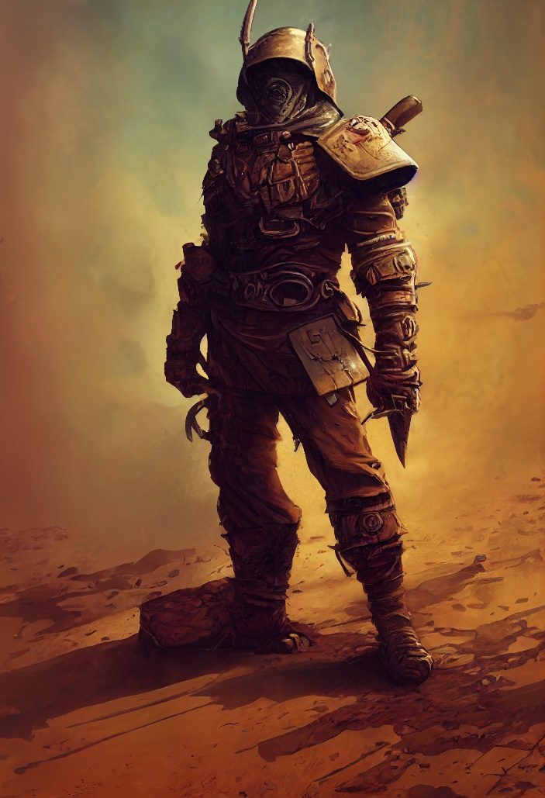

## ZHDANT OF THE DZAQTLAS ERA

|  |  |  |  |
| --- | --- | --- | --- |
| Pre-Dzaqtlas Zhdant | C654878-7 | Ag, An | Population: appx. 2x108 human, 1x107 chirper |
| Post-Dzaqtlas Zhdant | X654778-3 | An | Population: appx. 4x107 human, chirpers extinct |

Several careers are open to Dzaqtlas-era Zhdantia characters, depending on the character’s origin. Characters from one of the civilized *Dlenchiepr* houses of Western Dleqiats have many options depending on their level of psionic ability. One with high psionic skill is likely to be a shaman, healer, seer, or a member of the priesthood as either *Tozjabr* (Bringer of the Word) or *Tavrchedl* (Guardian of the Word). Others with less talent may follow any of the “standard” career paths, as outlined in this supplement.

Careers follow the same format as outlined in the Core Rules.The full details of each career track are outlined in the next section. The major difference is that Zhdantia characters’ career terms are one *Teqozdij* (Olympiad) of three *chten* or years each. Advanced age affects characters as follows:

1. Mongoose Traveller Alien Module 4: Zhodani, pp. 57-61